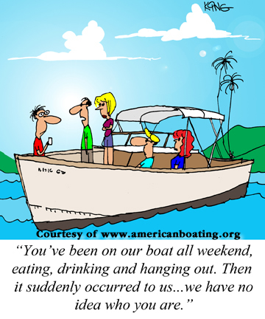
Cruise Planning

To go beyond what most boaters do on a weekend, requires one to leave their normal cruising areas and comfort zones. The Cruise Planning course focuses on the planning and preparation necessary for safe enjoyable extended cruises. We are very fortunate to have several seasoned Instructors that have many miles under their keels. Dave Clifford will be heading up the course. He will be joined by our very experienced long-distance cruisers, Lynn Heesen, Joann Jordan, Luke Curtis.
Rick Edel will spend an evening doing the Border Crossing Seminar. Hope you will join us and share your experiences and gain some new knowledge.

We will cover:
Cruise preparation and planning
Boat and Equipment
Anchors and Anchoring
Security
Chartering
Cruising Outside the United States
Crew and Provisioning
Voyage Management
Communications
Navigation
Weather
Emergencies

Join us
Tuesdays beginning March 17th - May 5th (7-9pm)
Contact: Dan Leenhouts diverdan1020@yahoo.com 206-419-7830
or Dave Clifford jodaclifford@gmail.com (206) 910-2859
Cost $65.00 Share a book for $20.00 more

