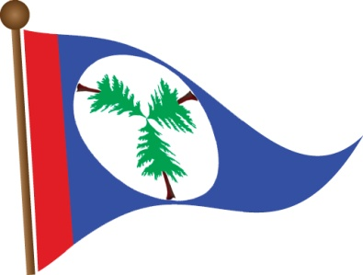
Three Tree Point Yacht Club
P.O. Box 98700
Des Moines, WA 98198
Visit us at www.ttpyc.org

August 20, 2020

Des Moines City Mayor, Council Members, City Manager and Staff
City of Des Moines
21630 11th Ave S Suite A
Des Moines, WA 98198

Dear Ladies and Gentlemen,
I am Doug Andrews, Commodore of Three Tree Point Yacht Club. I am writing to let you know the opinion of the yacht club regarding the paid parking at the Des Moines Marina.
After discussing this issue with our Trustee members we wanted to express the need to keep the paid parking at the marina as is. The paid parking has been a great help for the marina moorage tenants, we feel safe keeping our cars in the parking lot overnight, and feel safe walking to our cars in the evening now that the parking lot closes at night. The loud cars and impromptu parties in the north lot have ceased. Club members who live in the condominiums around the marina no longer have to be disturbed late at night for the unruly behavior of a select few.
Again the members of the Three Tree Point Yacht Club are very happy with the paid parking as it is. We hope you will consider keeping the paid parking.
Sincerely,
Doug Andrews
Commodore
Three Tree Point Yacht Club

